YARCOMBE PARISH COUNCIL MINUTES
Remote Meeting held via Zoom, Monday 4th January 2021 at 8.00 pm
In Attendance:
Cllrs C Stone (Chair), T Long, L Pidgeon, C Ford, S Horner, D Little, D Barnes, C Vining, S-J Martin (Clerk & RFO)
Members of the Public present – 0

Cllr Stone welcomed everyone to the meeting and thanked Cllr Iain Chub for joining us.

1. Apologies for Absence:
Cllrs D Key, C Brown, and S Vining.

2. Declarations of Interest
Cllr Stone asked if anyone had any Declarations of Interest for the meeting, to which none were declared.

3. Minutes.
The Councillors were asked if they were happy that the Minutes of the Parish Council Meeting held on Monday 2nd November received by email, were correct and that everyone was happy for them to be signed. Everyone agreed and they will be signed as a true record outside of the meeting.
4. Reports
To receive the following Reports
- County Councillor – Cllr Iain Chubb
Cllr Chubb advised he would send his December report to the Clerk – see addendum at end of Minutes, circulated to the Councillors but that it could be a “bit old hat” with the imminent announcement from Boris Johnson. Cllr Chubb advised the report contains updates on the vaccinations and a drainage report with a useful link in the enclosed. There are continuing school issues relating to the Covid situation, and concerns relating to care for the elderly and vulnerable.
Cllr Chubb had been in the Upottery meeting which had on the Agenda Broadband, and things are starting to roll with this now with various Organisations on-board and Monkton now has live Broadband.
Roadworks are getting done and a lot is coming through the new pilot scheme “Doing What Matters” but there is the issue of too much work and not enough money.
Cllr Stone asked if any of the Councillors had any questions. None were raised but he raised that Yarcombe is a pilot for “Doing what Matters” and the drainage link with works due to be completed in our area sounds very interesting.

b. District Councillors – Cllrs D Key and C Brown
No reports received
c. Police
No report received
d. Yarcombe Community Land Trust
Cllr Horner read out his report, forwarded to the Clerk as follows:
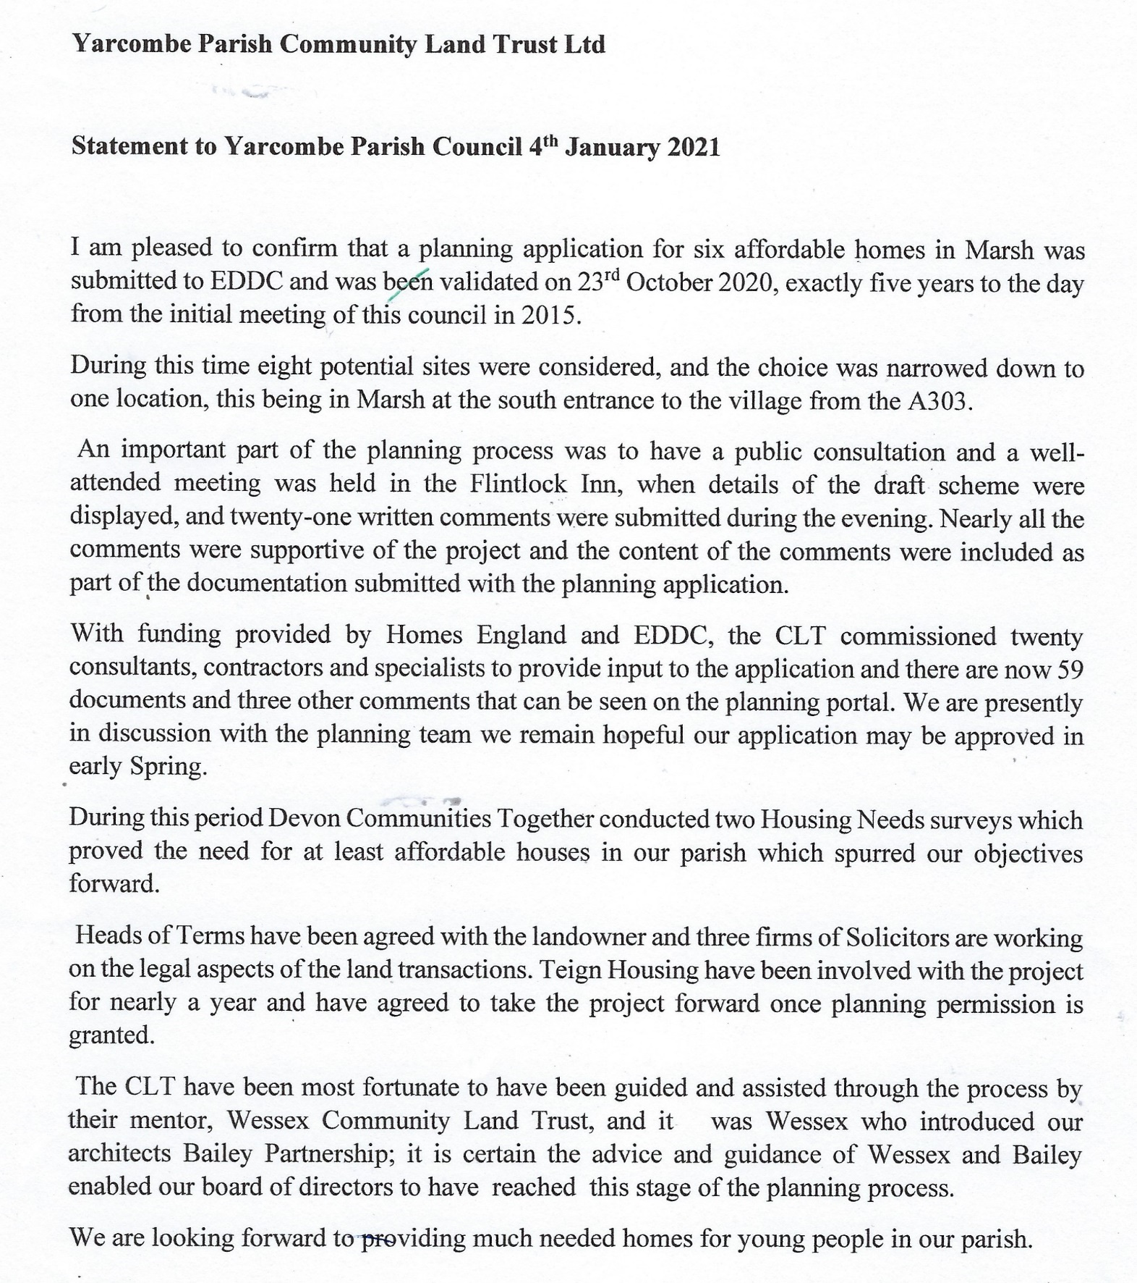

Cllr Horner asked if anyone had any questions to which Cllr Ford asked why it had taken so long to which Cllr Horner replied, that there were 59 reports for the planners to go through and as Yarcombe is regarded as a “non-sustainable community” all these reports plus other submissions had to be read.
Cllr Barnes said Cllrs Stone and Horner had worked very hard on this project and that it will be an asset to Yarcombe and Marsh.

Cllr Chubb advised that with Planning, it is a very fine art and acknowledged that affordable housing is required. Cllr Horner responded that the project is all affordable housing, and it will remain in perpetuity in that the housing will be leased to a housing association then on expiry of the lease, the properties will revert back to the trust. Cllr Chubb said EDDC were trying to set up a separate housing scheme so that if properties were sold, monies reverted to EDDC and not to the Government. He also added Geoff Pook, a Beer Councillor and Sheila at Dalwood would be helpful to which Cllr Horner advised Sheila at Dalwood was our Mentor.

e. Reports from Individual Councillors
All the Councillors were asked if they had anything to report, those that did were as follows:
Cllr Long:
Commented that the Parish Councils views on planning applications are always considered views and advised Cllr Chubb that he would like Cllr Key to work more closely with the Parish Council and our Parish Plan, with consideration to our comments before he made his comments on applications. It would also be beneficial if he was to back our views on applications. Cllr Chubb commented that Cllr Key should be neutral.
Cllr Little:
The defibrillator is regularly checked, and it is working well.
Cllr Ford:
Cllr Horner has been a fabulous parish paths walker and has reported lots of issues which need attending to. He was also very helpful when we received a complaint regarding a footpath which turned out to be land not related to the designated footpath.

5. Parish Council Priorities – Ongoing projects:
- Village Facilities / Amenities
Administration payment to the Voices
We made an administration payment to the Voices last year of £100 and a Grant payment under S146 for £100 and it was discussed as to whether we could make one payment of £200 to cover the administration undertaken for all our notifications and entries in the Voices we request.
RESOLVED – The Councillors agreed a £200 administration payment should be made.
Accessibility of Parish Council website
On-going - It has been decided we shall obtain a new website through https://parishcouncilwebsites.org.uk in the next Financial Year. It was agreed in the October meeting that a standard ready-made website specifically for Councils is the one we should opt for which also is GDPR compliant and can provide council specific emails for all the Councillors.
Cllr Chubb advised we may be able to obtain Councillor specific emails through EDDC and advised us to contact democratic services at EDDC. He also mentioned he had some Locality budget which we could apply for to be used for our new website which all the Councillors are very grateful for.
Update on a Defibrillator in Marsh
Sandra Newton has advised they still need to raise some more funds which is slow going due to Covid. Once in place, we will cover it on out Parish Council Insurance Policy.
Landmark Trees
To consider a brass plaque near the tree – this is postponed until it is safe to have a gathering and place the plaque. Cllr Horner has advised Timpson’s in Taunton do good engraving.
- Highways
Community Speed Watch
It has previously been decided to defer the further consideration of this until Spring 2021.
Potholes
Amy Tucker from Lower Luxton Farm has reported potholes on the stretch of lane from Knapp Farm towards Williambear and complaining they have not been done. Since the meeting, Highways have reported this is scheduled for repair and Clerk has asked Amy to keep us updated.

- Additional Items
Review of Standing Orders
Their review is on-going.
Sandbags
This remains on the Agenda as we shall require some more in 2021.
Planters on the layby
We received letter from Lesley Sutton who would like to thank whoever swept the acorns on the layby as it was getting treacherous. But – that the plant troughs are looking very sad. Lesley suggests they need less time-consuming plants and ones which will survive lack of water as there is no water up there.
There was a discussion re the plants as some thought they didn’t look too bad. Tony Baker had been attending to the planters so we shall wait until the spring to see what they look like then and see if anything has been done with them.

Playground Area
Cllr Pidgeon wants everyone to know that there was a notification on the Yarcombe Facebook page that there is a group set up called “Improve Yarcombe” with a view to getting a play area set up in the village, behind the village hall.
Cllr Little advised there was a play area in the village 30 years ago but then there were 30 children getting on the school bus. The facility wasn’t used and that was when the tennis court was put down instead.
The Councillors discussed the site size as always having been an issue and that before the Parish Council did anything, we would wait for them to contact us.
Cllr Horner knows the lady who is looking for this facility to be instigated but advised there would need to be a Sub-Committee, Directors would need to be appointed, there are on-going Health and Safety concerns and Insurance costs. The facility in Bishopswood cost £10,000 with Insurance costs on top.

6. Open Session for Public Participation
No members of the Public were in attendance.

7. Finance
a. The Councillors received the Clerks report on the current Financial Position by email and Cllr Stone asked if everyone was happy with the finances. None of the Councillors had any comments.
b. Payments within the Clerks Report schedule were agreed:

Payment Date | Payee | Details of Payment | Amount
05.01.21 | HMRC | November PAYE | 59.50
05.01.21 | HMRC | December PAYE | 60.10
05.01.21 | S-J Martin | November Clerks wages | 239.20
05.01.21 | S-J Martin | December Clerks wages | 239.20
29.12.20 | Society of Local Council of Clerks | ILCA Course for Clerk | 118.80

c. The Budget had been sent to the Councillors in readiness to discuss the Precept requirements for 2021/22.
Due to the very generous offer of Cllr Chubs Locality Budget to cover the cost of the website, it was decided that the Council will show constraint during this time of Covid and not request an increase in our precept.
RESOLVED – The precept will remain the same as requested in 2020/21.

9. Planning
To receive and endorse the Planning Decisions of the Council taken since last meeting under delegated authority.
Cllr Long advised that during this time, site meetings have been held with a skeleton of Parish Council members, where he felt it necessary and consequently hasn't been inviting all the Parish Councillors to all the applications, due the present circumstances.
Cllr Long went through the current applications within the Agenda and advised he would say this cautiously, but he was a little quiet.
Cllr Stone asked if everyone was happy, then he would close the meeting.

The date of the next meeting is Monday 1st February at 8pm which will be held remotely.

Addendum:

Division members report to Blackdown & Whimple

December 2020 – DCC Cllr Iain Chubb
Care home COVID-19 Testing
As is well documented older people are generally more vulnerable to contracting COVID and the challenge is to given them maximum protection, keep them out of an acute hospital setting and through no fault of the own using up resources.
However, the Department of Health and Social care are about to launch a huge expansion of testing in care homes, with their pledge being that by the 18th December all care homes will have received sufficient test kits to enable ...
All staff to be tested twice a week
- All residents to be tested weekly
- Up to 2 visits by 2 visitors every week (i.e. testing for up to 4 visits a week for every resident)
Most of the test kits will be the new ‘Lateral Flow Devices’ which give results in less than 30 minutes. This is good news for the many care homes in East Devon and beyond.
This is a small-scale pilot involving eight care homes in Devon and DCC are one of three Local Authorities (also Hampshire and Cornwall) who were selected, based on low prevalence rates.
The aim of the pilot is to examine the role of how testing of visitors, alongside other existing infection prevention/control measures, maximises safety. It will run for four weeks from 16 November to 13 December 2020. Homes received training through online webinars on 12/13th November before commencing the pilot on 16th November.
The testing will use a combination of new rapid-results tests as well as the tests already in use:
Weekly swab testing of regular visitors, using existing PCR swab testing technology
new Lateral Flow Devices (LFD) tests which are taken before visitors enter the home with results available within 15 to 30 minutes.
As LFDs are new technology, any positive tests will be confirmed with a PCR test.
Feedback from the homes is collected through weekly online sessions, facilitated by the DHSC has been mainly positive, reporting that the process is simple to follow and meaningful contact whilst wearing full PPE is appreciated. Relatives and residents have been very emotional with the pilot bringing hope and a glimpse of the new normal.
30 visitors had been tested as of 20th November. One visitor tested positive and went home to isolate whilst awaiting the result of the PCR result. One visitor refused testing because they didn’t feel comfortable
Mass vaccination programme

The national COVID-19 mass vaccination programme is to commence in December 2020. The focus of initial vaccination will be in staff and residents in care homes and those over 80 years of age.

A significant amount of work is taking place locally across the Devon wide system to co-ordinate activity and ensure coverage across the county, and that there is an awareness how and when people can access the vaccine at their GP or regional centre (Exeter).

The Exeter Nightingale has now received its first COVID-19 patients

Since the beginning of July, the Nightingale Hospital Exeter has been providing local people with fast and safe access to a range of important diagnostic tests. These additional services will now stop at the Nightingale facility to allow the hospital to care for COVID-19 patients. Diagnostic tests will continue to be available to those who need them through existing diagnostic services across the region.

The 116-bed hospital is designed to provide care for patients with COVID-19 and can support both ventilated and non-ventilated care. Patients with COVID-19 who need the additional services available within an acute hospital will be cared for there.
Waste and recycling
All DCC our recycling Centres are open, but from recent personal experience in recent weeks very quiet.
Winter opening hours are in operation for most sites this is 9-4.30 Monday to Friday and 10-4.30pm Saturday and Sunday. They will be closed on Christmas day, Boxing Day and New Year’s Day.
Highways
I am pleased to report that volumes of work across the Highways teams remains really high, and the recent wet weather has seen a significant number of problems on the network, but this has not held up the winter maintenance programme which officially started on the 15th of October, with the salt barns fully stocked, and all vehicles ready.
Additional COVID related contingency plans are also in place should they be required. In many ways we are quite fortunate to have as many depots as we have including one in Honiton that serves the eastern end of East Devon. You may have seen recently that the new Network Operations Control Centre that has been set up now in Great Moor House to make sure our roads stay functioning throughout the year.

With the recent lockdown, traffic flows on the A road network have again fallen, during the last couple of weeks week by about 30% and at weekends by about 40%, compared to the equivalent week in 2019. With schools remaining open the morning peak flows are virtually unchanged; the main changes are during the daytime and evening periods.
The DCC Highways Asset Team are extremely busy delivering our highest ever capital programme. This larger budget is allowing us to look beyond the normal priorities of our main A roads and address some of the deterioration on our important lower category roads. These improvements and renewals across the network are beginning to be noticed by the travelling public as this work continues.
As ever, at this time of year, the DCC gully cleaning policy is under scrutiny as we experience a combination of leaf fall and an extended period of wet weather. The team have carried out a detailed review of our approach to drainage cleaning which has resulted in several improvements.
The second Doing What Matters project focused on the rebuild of the safety defect process and is now beginning to look at new software development with a view to rolling out a trial ‘beta’ system in the New Year. The primary aim of the project is to improve the number of defects repaired at the first visit. In order to achieve this, we are investing in the amount of advance information recorded by our Safety Inspectors
A useful link to help with drainage in Devon, this shows all known drainage with scheduled inspection and maintenance:

https://apps1.wdm.co.uk/Live/Devon/PBLC/PIP/map.aspx?cg=kaarb

